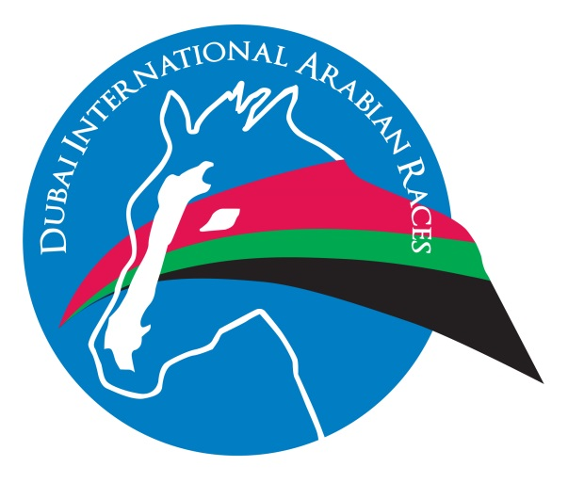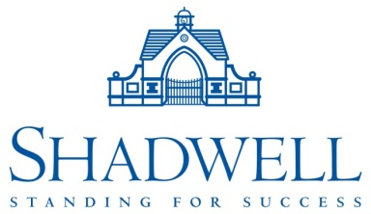

MEDIA RELEASE: FOR IMMEDIATE RELEASE

First Listed Race for Arabians a triumph in Rome for DIAR.

Sunday 8 May saw the renewal of Shadwell’s sponsorship of a day of thoroughbred racing at Rome’s Capannelle Racecourse supported by 2 Arabian races under the banner of the Dubai International Arabian Races.

The Arabian races included the first ever IFAHR approved stakes race to be run in Italy, the Premio Dubai International Arabian Races 2016 (Listed PA). The 1900m race for colts, fillies and geldings of 4 years old and up attracted 15 runners including international competition from France and Holland headed by VULCAIN DU CLOS. The son of MONSIEUR AL MAURY travelled easily throughout the race and finished strongly to take the first Listed PA contest in Italy from the Karin van den Bos trained ATHLETE DEL SOL.

Speaking on behalf of the owners, the Royal Cavalry of Oman, Chloe Marchandet of the FBA said:

“We are very happy with this win. It is his first race of the season since his 2nd place in Casablanca at the end of last year. His programme is aimed at international races and we hope he will return to DIAR Newbury on 24 July where he won the Emirates NBD Conditions Stakes in 2015.”

VULCAIN DU CLOS, ATHLETE DEL SOL and the highest placed Italian horse TORNADO BYZUCCHELE (3rd in the race) will all be eligible to compete at Newbury on 24th July for the DIAR Bonus Fund of 2016.

The addition of an IFAHR Listed race to the programme of races on “Dubai Day” was the culmination of the hard work of the Ministry of Agriculture in Italy and the Italian Arabian organisations responsible for breeding and racing ANICA and IREAHA. ANICA representatives:

“We are very pleased to have our first Listed PA race in Italy and we would like to thank HH Sheikh Hamdan bin Rashid Al Maktoum and the Dubai International Arabian Races for supporting Arabian racing in Italy for the last 5 years. This is a great start for our international development and we hope to build on today’s success.”

The Listed race was complemented with the Premio Shadwell Arabian Stallions Stakes, a conditions race aimed at Italian horses. This was an 11 runner race over 1500m. Of particular note in this race was the Stephano Botti owned and trained UNU DI GALLURA-PSA. Botti, one of the most successful trainers of Thoroughbreds in Italy has recently started training Arabian horses. The interest of such a prominent trainer in Arabian racing is an illustration of the enthusiasm the Italians have for their new found international status.

It was however Endo Botti who trained the winner of the first Arabian race of the day. URGE DI GALLURA, an unbeaten 3YO colt ran an excellent race to finish clear of a competitive field. Endo Botti has 100 thoroughbred horses in training and now 6 Arabian horses in his yard in Tuscany. Speaking after the race Cristina Brivio Sforza of Soc. Allevamento Razza Latina said:

“The horse is unbeaten and improving with each run. We hope to run in a race on 29 May in Rome with the ultimate goal of travelling to Newbury in July to contest the Gr.2 PA Emirates Equestrian Federation International Stakes.”

To celebrate the first Listed PA race run in Italy, Shadwell Arabian Stallions made a prize draw among the Italian owners and breeders for a free nomination to MADJANI: this was won on the day by Mr G Floris, the owner of TABASCO, a runner in the Listed contest. All other entrants in the draw have been offered free nominations to JIYUSH and EAU ROYAL – a gesture from Shadwell Arabian Stallions to support the breeding of Arabian horses in Italy.

In addition to the Arabian races, companies from Dubai including Emirates Airline and Jebel Ali Racecourse, sponsored a card of Thoroughbred races with a total of 58 runners between them. Shadwell and its partners have been supporting Thoroughbred racing in Italy for over 15 years; the work is particularly important as Shadwell stand 2 Thoroughbred stallions at Allevemento Besnate. MUJAHID is a multiple Champion sire in Italy and the sire of CLEO FAN the last winner of the Premio Presedente della Republica while it held Gr.1 status. Besnate have recently taken over management of the Gr.1 winning son of Oasis Dream, ARCANO who is standing his first season in Italy and proving popular with breeders.

RACE RESULTS 8 MAY 2016 – ROME CAPANNELLE:

Premio Shadwell Arabian Stallions Stakes (Arabian Race)
URGE DI GALLURA
O: Razza Latina
T: Soc All E Botti
J: C Fiocchi

Premio HH Sheikh Hamdan bin Rashid Al Maktoum Stakes
ELUSIVE QUEEN
O: SC Chimax
T: Att Giorgi
J: D Vargiu

Premio Jebel Ali Racecourse Stakes
CHICCHESSIA
O: F Turri
T: M Gasparini
J: L Maniezzzi

Premio Dubai International Arabian Races 2016 (Listed PA) (Arabian Race)
VULCAIN DU CLOS
O: Royal Cavalry of Oman
T: C Gourdain
J: D Morrisson

Premio Tadolina UAE Embassy Stakes
AURY TOUCH
O: SC STE MA
T: A & S Botti
J: D Vargiu

Premio Emirates Airline (Listed)
PORTO BLANCO
O: SC DELL’AVVOCATO
T: P Giannotti
J: L Maniezzi

Premio Mario Perretti MUJAHID Stakes
PLEIN AIR
O: SC New Age SRL
T: A & S Botti
J: Ant. Fresu

Premio Shadwell Stakes
PRETENDING
O: EFFEVI
T: A & S Botti
J: F Branca

NOTES FOR EDITORS:

The Dubai International Arabian Races is an international programme of Arabian racing run under the patronage of HH Sheikh Hamdan bin Rashid Al Maktoum, UAE Minister of Finance and Deputy Ruler of Dubai.

More information about DIAR can be found at www.diaraces.com

Arabian Racing in Italy is run by the Italian Ministry of Agriculture and in association with ANICA.

Italy became a full member of the IFAHR (International Federation of Arabian Horse Racing) Pattern Programme in 2016.

